**Ministry of Agriculture, Land and Fisheries**

Livestock Unit

#### Purchase of breeding stock

#### Criteria used in assessing farmers selected for breeding stock include:

1. Source of farmer’s current stock and animal health
2. Feeding and nutrition.
3. Farmers training and experience.
4. Livestock housing and the environment.
5. Focus of small ruminant enterprise.
6. Record keeping measures.
7. Location of farm.
8. Date of request.

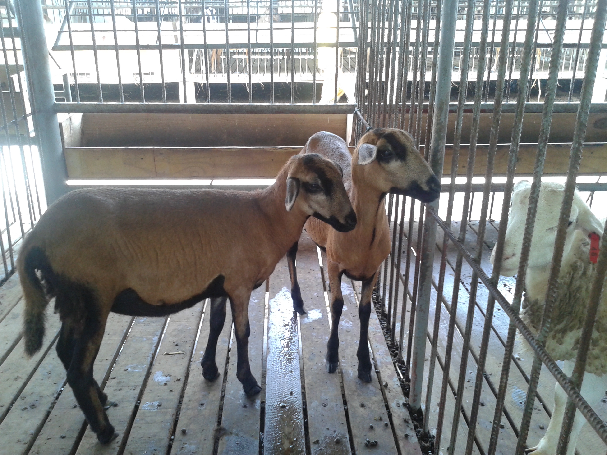

Barbados Blackbelly lambs for sale

**Process of animal purchase:**

1. A request is made at locations listed via telephone or in person.
2. Applicant is contacted and a field visit is conducted to ascertain defined criteria for distribution.
3. Applicant is sorted on shortlist and contacted when animals are available for sale.

**Animals can be purchase at the following locations:**

* Cedros Breeding Unit, Bonasse Village, Cedros. Tel: 690-1373
* Penal Demonstration Station, Ramjattan Trace, Penal. Tel: 647-8460/1167
* Rio Claro Demonstration Station, Pond Road, Ecclesville. Tel: 644-2326/2882

NB. Animals purchased at Rio Claro Demonstration Station and St. Patrick West County Office are located at Mayaro Breeding Unit and Cedros Breeding Unit respectively.

# Sale of small ruminants (Sheep and goat)

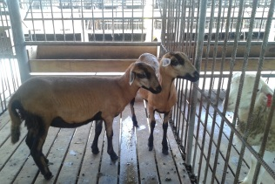

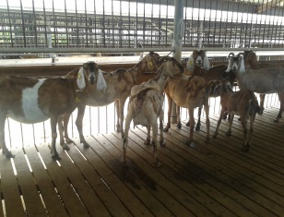

Regional Administration South Division

# 

Saanen kids for sale at Mayaro Breeding Unit

# Sale of breeding stock

The Ministry sells small ruminants as breeding stock to farmers to improve and expand their herd with suitable breeds.

**Farmers who currently own sheep or goat are eligible to purchase animals.**

**Additionally, registered farmers under the age of 40, who do not own sheep or goat, possess livestock training certificate(s) and housing for animals, are also eligible to purchase animals.**

# Price of animals sold as breeding stock

Breeding stock is sold at the Ministry’s scheduled price of:

* $14.00 per kg for male sheep
* $13.00 per kg for female sheep
* $32.00 per kg for male goats
* $30.00 per kg for female goats

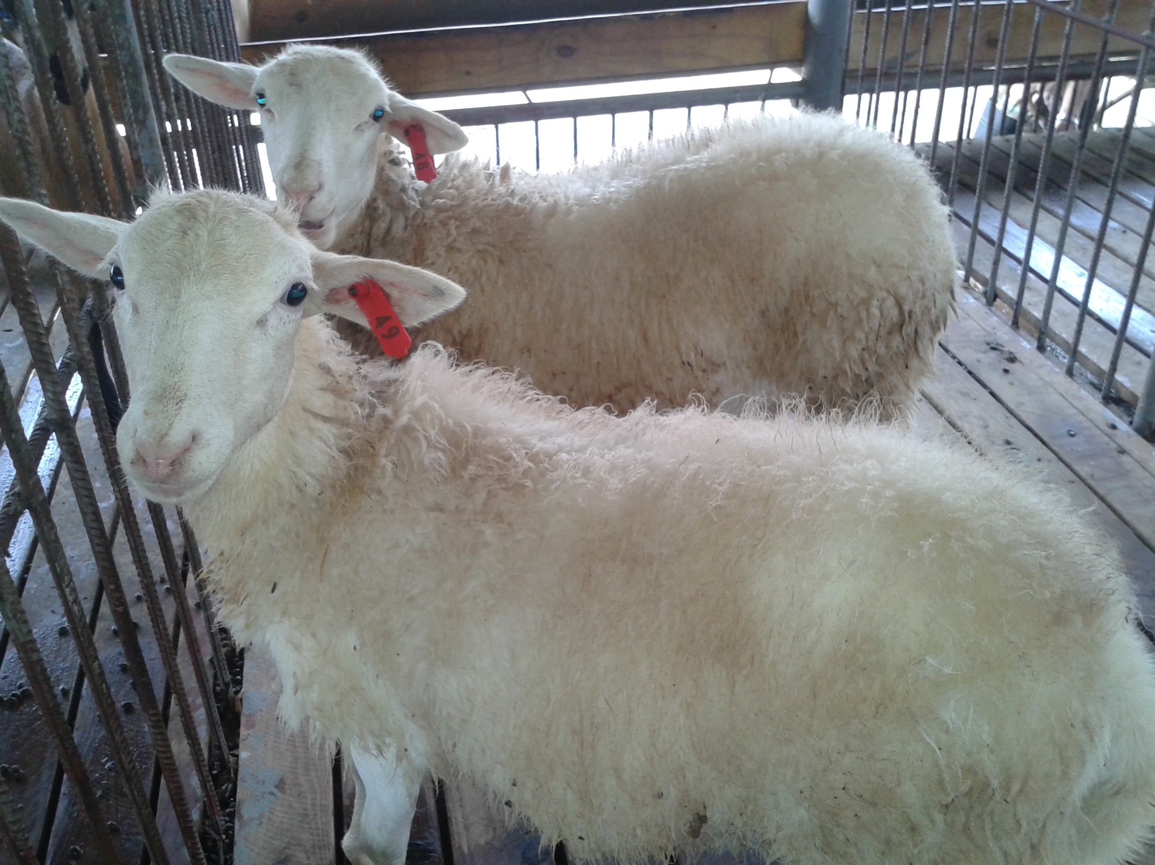

Katahdin lambs ready for sale

# What breeds are available for sale?

Breeds of sheep: Barbados Blackbelly, West African and Katahdin.

Breeds of goat: Anglo-Nubian and Saanen.

The breeds available varies based on the Livestock Station.

# What is the average weight and age of breeding stock available for sale?

Breeding stock for sale are usually lambs/kids that range from 15kg to 45kg with an age range of 4.5 – 6 months.

In some cases, animals that are no longer required as part of the Ministry’s breeding stock, usually adults animals, are also sold as breeding stock or cull.

#### Sale of sheep and goat